

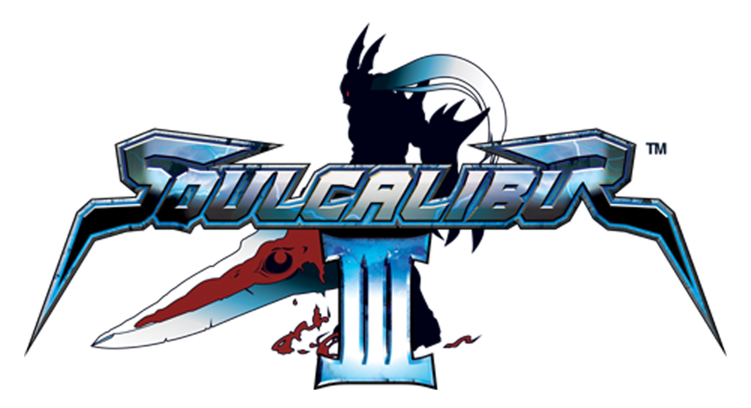

Junichi Nakatsuru / Sound Director and Composer Interview

- Name, position and length of time working in the music industry?
- Mr. Junichi Nakatsuru / Sound Director and Composer / Approximately 16 years

- What was the first game you played?
- Namco Pole Position (Arcade Game)

- What instruments do you play/ what level/ grade?
- Piano and Keyboards which I play even now. Also, I used to play the Trombone in a brass band in high school.

- Who are your favourite Western bands/ have you seen them in concert?
- Pat Metheny Group and Incognito. I go to their concerts every time they come to Japan.

- Have you ever been in a band or an orchestra?
- I was a member of my high school’s brass band. In university, I played in a jazz fusion band and we played original music, not cover versions. But I also played with a number of bands who tended to play cover music.

- How long have you been composing for?
- I think I have been composing for roughly 20 years or so.

- Have you composed for any other games?
- Ace Combat Squadron Leader, Ridge Racer PSP and Taiko no Tatsujin etc. I have worked on the entire SOULCALIBUR Series.

- What is on your ipod?
- Jazz, movie soundtracks and of course all of my own compositions

- Who is your all time favourite composer?
- I don’t have any favourite composers but I do sometimes enjoy movie soundtracks.

- What has been your strangest/ most embarrassing musical moment?
A. The most embarrassing moment must have been during a live concert of a band I was playing with. During the rehearsals everything went well but for some reason my keyboard malfunctioned when the actual live performance started. The performance continued so I reluctantly ‘pretended’ to play. That was very embarrassing…

Where do you compose? Do you have a special room or a special time of day where you are most inspired?
A. Basically I compose at my booth or the studio in my office, although the musical concept usually comes to me during my commute on the train. The problem is I tend to forget my ideas by the time I get to the office. Many masterpieces have been lost on my way to the office. (laughs)

- How important do you feel music is in adding atmosphere for the game?
- Music in games is composed of three elements: sound effects, voice-overs and music. All three are crucial components and it would not be the same with any one element lacking. Music needs to be used effectively, music is not effective if it is played consistently throughout the game; for example playing the music to build up to a climax or conveying emotions are methods of effective musical use.

- Do you think the quality of music in games is equal to the quality of film scores?
- The quality of music in games has reached a point where it is very close to film scores. Surround sound is now common in games as well as using orchestras for in-game music (SOULCALIBUR III uses both). Film music used to be at a higher level, but game music is nearing that level and I feel that we need to strive to achieve the same level – games need to be at the same level.

- What is your favourite music in a Hollywood film? Why? What do you think it adds?
- I like music from action and history genres movies. I was also influenced by many things when I was composing for SOULCALIBUR III. What is common with games and films is that music helps make the storyline more compelling and shows character emotions with more drama and richness.

- Can you explain the timeline behind your Soulcalibur composition? How much did you know about the game before you started working on the music – and did you make any changes to the music after you saw the completed game?
- It took approximately half a year for all Soulcalibur III compositions to be completed. The actual composing time frame was less than that but I had to make some changes during the game development. I have been in charge of the music for all of the SOULCALIBUR titles, so I had a good understanding of the game system and the SOULCALIBUR universe. As the game development progresses I often go back and re-make, re-work my previous work in the hope of making them better.

- What do you think is in store for the future of music and gaming?
- Consoles are entering a new era of hardware and I think the methods of expression will increase. What will be required from future games is how to effectively use that increased method of expression. Music will implement higher quality surround sound and multi-channel audio will become more common. But again, how you use that technology to present music – the total presentation of not only music but sound – will be critical.

- What do you think are the specific challenges of composing music for a game rather than a film?
- The biggest difference is games are interactive. Storylines in movies progress in line with the creators’ intent only, whereas the players’ objectives have an impact on the course of a game. Game creators have to prepare for all courses that players take and all the factors that are involved. That is one of the difficulties of creating games, but also the challenge.

- If you could have composed music for any Hollywood film, which one would it have been and why?
A. If I could, I would love to compose any genre! If pressed I would say an action or a historical film, of course I would welcome a romantic comedy too.

Visit our website:
www.soulcalibur-3.com

Notes to Editors

Developer: Namco Genre: Sword-fighting Action
No. of Players: 1-2 Platform: PlayStation®2
Peripherals: Analog Controller (DUALSHOCK®2), Memory Card (8MB) (for PlayStation®2)
Release Date: Quarter 4, 2005

About Sony Computer Entertainment Europe Ltd.
Sony Computer Entertainment Europe (SCEE), based in London, is responsible for the distribution, marketing and sales of PS one®, PlayStation®2 and PlayStation® Portable software and hardware in 104 territories across Europe, the Middle East, Africa and Oceania. SCEE also develops, publishes, markets and distributes games software for the three formats, and manages the third party licensing programs for these platforms in the PAL territories. At the end of June 2005, over 40 million PlayStation® units had been shipped across these PAL territories, over 102 million worldwide. Between its European debut on 24 November 2000 and 20th July 2005, over 33 million PlayStation®2 units have been shipped across the PAL territories, over 91 million world-wide, making it one of the most successful consumer electronic products in history. Between the launch of the PSP in Japan in December 2005 and 21 July 2005, over 5 million PSPs have been shipped worldwide.

PlayStation and the PlayStation logo, PS one and PS2 are registered trademarks of Sony Computer Entertainment Inc. PSP and UMD (Universal Media Disc) are trademarks of Sony Computer Entertainment Inc. All other trademarks are property of their respective owners.

More information about PlayStation products can be found at http://www.scee.com , www.yourpsp.com and www.playstation.com or visit the Virtual Press Office at www.scee.presscentre.com

Namco Limited
Namco, with headquarters in Japan was established in 1955 and has consistently provided a high level of expertise in the entertainment industry. With games such as Tekken™, Ridge Racer™, Timecrisis™ and Acecombat™, Namco has become a successful developer and publisher, esteemed throughout the world for the games of excellent quality it has produced.

Tekken™, Ridge Racer™, Timecrisis™ and Acecombat™ are trademarks or registered trademarks of Namco Limited. Namco is a registered trademark of Namco Ltd. All rights reserved.SOULCALIBUR™III & ©1995 1998 2002 2003 2005 NAMCO LTD., ALL RIGHTS RESERVED.
NAMCO is a registered trademark of NAMCO LTD. All other trademarks and trade names are the properties of their respective owners.

